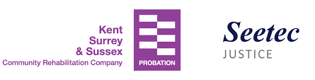

Community Payback
supporting the Winter Shelters in your area

Community Payback in Kent, Surrey & Sussex are pleased to be offering Unpaid Work Hours to support shelters again during the Winter 2019-20 season

Building on what we learnt in Kent last year, we are preparing now so that we are ready to meet your needs

Please contact me NOW on 07796840791 or sharon.moxon@ksscrc.co.uk
so that we can discuss & be ready to help

I look forward to hearing from you

