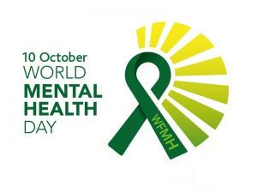

World Mental Health Day 2019: focus on Suicide

Every 40 seconds, someone loses their life to suicide.
Join us, on 10 October, in “40 seconds of action” to raise awareness of the scale of suicide around the world and the role that each of us can play to help prevent it. Please download this poster to help us all work together to prevent suicide.
https://www.who.int/docs/default-source/mental-health/suicide/flyer-40seconds-web.pdf?sfvrsn=5ba643c_2
Elle Weaver, writes about Suicide Prevention
Suicide prevention remains a universal challenge. Every year, suicide is among the top 20 leading causes of death globally for people of all ages. It is responsible for over 800,00 deaths each year, which equates to one suicide every 40 seconds. It is the leading cause of death in people aged 15-24 years. For every suicide 25 people make a suicide attempt. With the rates of suicide, it equates to 108 million people bereaved by suicide worldwide every year.
Joining together is critical to preventing suicide so we can all make a difference – as a member of society, as a parent, as a friend, as a colleague, as a neighbour. We can raise awareness about suicide, we can educate ourselves and others about the causes of suicide and the warning signs, we can show compassion and care for those who are in distress in our community, question the stigma associated with suicide and share our own experiences.
Two of the leading factors that contribute to suicide is isolation and feeling like a burden
Everyone can contribute in preventing suicide. Suicidal behaviour is universal, know no boundaries so if affects everyone. The listening ear of someone with compassion, empathy and a lack of judgement can help restore hope. Take 40 seconds to reach out to someone in your community, a friend, family, colleague or even a stranger – we could change the course of another’s life.
One life lost to suicide is one life too many!
Elle Weaver, Mental Health and Wellbeing Facilitator, Together in Sussex

